

RAJALAKSHMI ENGINEERING COLLEGE RAJALAKSHMI NAGAR, THANDALAM 602 105

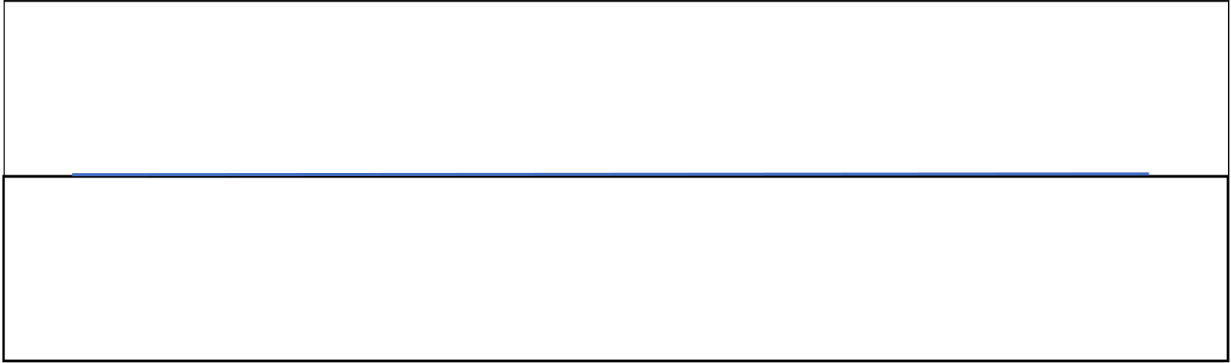
CS23331 Design and Analysis of Algorithms
Laboratory Record Note Book
Name :
Year / Branch / Section :
University Register No. : | .. | . | .
College Roll No. : | . | . | .
Semester : | . | . | .
Academic Year : | . | . | .

 | RAJALAKSHMI ENGINEERING COLLEGE  An Autonomous Institution

BONAFIDE CERTIFICATE

Name: | ……………………………………………………………………………
Academic Year: …………… Semester: …………… Branch: ………………
Register No.
Certified that this is the bonafide record of work done by the above student in
the..........................................................................................................Laboratory
during the academic year 2025- 2026
Signature of Faculty in-charge
Submitted for the Practical Examination held on……………………………

Internal Examiner

External Examiner

INDEX
EX.NO | DATE | NAME OF THE EXPERIMENT | GITHUB QR
1 |  | Basic C Programming | 
2 |  | Time Complexity
3 |  | Brute Force
4 |  | Divide and Conquer
5 |  | Greedy Technique
6 |  | Dynamic Programming

